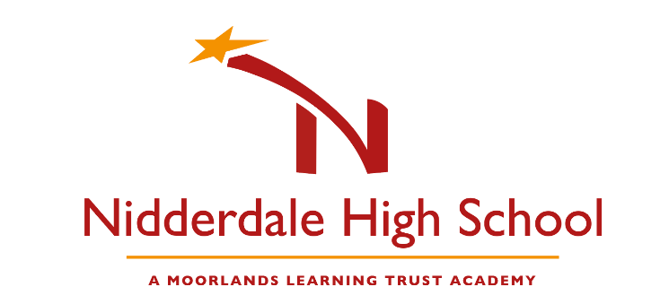
Instruction to your
bank or building society
to pay by Direct Debit
Please fill in the whole form including official use box using a ball point pen and send it to: |  |  |  |  |  |  |  |  |  |  |  |  |  |  |  |  |  |  |  | Service user number
Moorlands Learning Trust Academy  Nidderdale High School  Low Wath Road  Pateley Bridge  Harrogate  North Yorkshire  HG3 5HL |  |  |  |  |  |  |  |  |  |  |  |  |  |  |  |  |  |  |  | 7 | 8 | 0 | 9 | 6 | 3
FOR Moorlands Learning Trust (Nidderdale High School)
OFFICIAL USE ONLY
This is not part of the instruction to your bank or building society.
Name(s) of account holder(s)
Bank/building society account number
Branch sort code |  |  |  |  |  |  |  |  |  |  |  |  |  |  |  |  |  |  |  | Instruction to your bank or building society  Please pay Moorlands Learning Trust Direct Debits from the account detailed in this Instruction subject to the safeguards assured by the Direct Debit Guarantee. I understand that this Instruction may remain with Moorlands Learning Trust and, if so, details will be passed electronically to my bank/building society.
Name and full postal address of your bank or building society
To: The Manager |  |  |  |  |  |  |  |  | Bank/building society
Address |  |  |  |  |  |  |  |  |  |  |  |  |  |  |  |  |  |  |  | Signature(s)
 |  |  |  |  |  |  |  |  |  | Postcode |  |  |  |  |  |  |  |  |  | Date
Reference
Banks and building societies may not accept Direct Debit Instructions for some types of account
DDI1

This guarantee should be detached and retained by the payer.


The
Direct Debit
Guarantee
- This Guarantee is offered by all banks and building societies that accept instructions to pay Direct Debits
- If there are any changes to the amount, date or frequency of your Direct Debit Moorlands Learning Trust will notify you 10 working days in advance of your account being debited or as otherwise agreed. If you request Moorlands Learning Trust to collect a payment, confirmation of the amount and date will be given to you at the time of the request.
- If an error is made in the payment of your Direct Debit, by Moorlands Learning Trust or your bank or building society, you are entitled to a full and immediate refund of the amount paid from your bank or building society
– If you receive a refund you are not entitled to, you must pay it back when Moorlands Learning Trust asks you to
- You can cancel a Direct Debit at any time by simply contacting your bank or building society. Written confirmation may be required. Please also notify us.

